Where participants of the study live

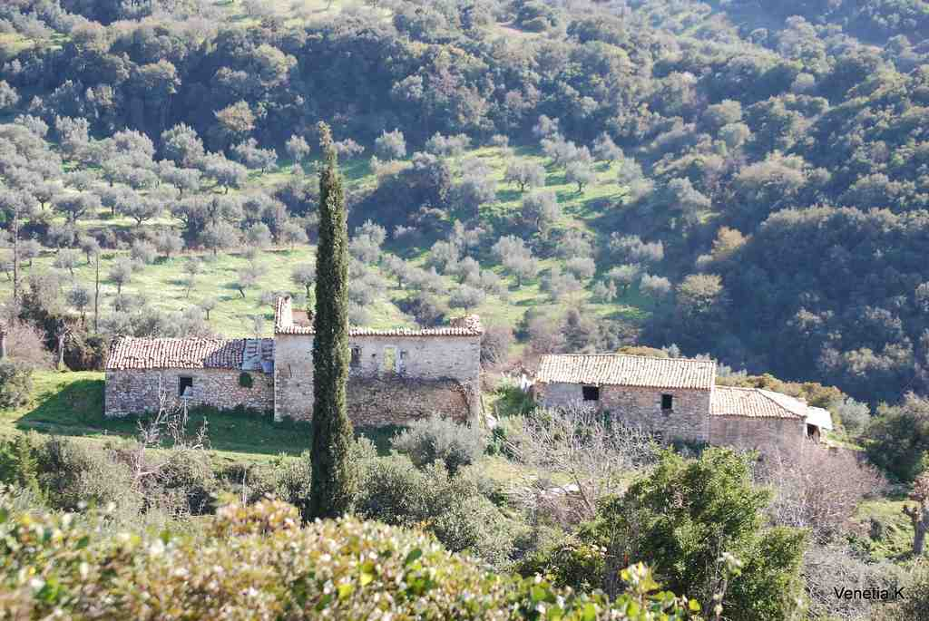
Rural Greece
Image courtesy of venetia koussia; image source: Flickr

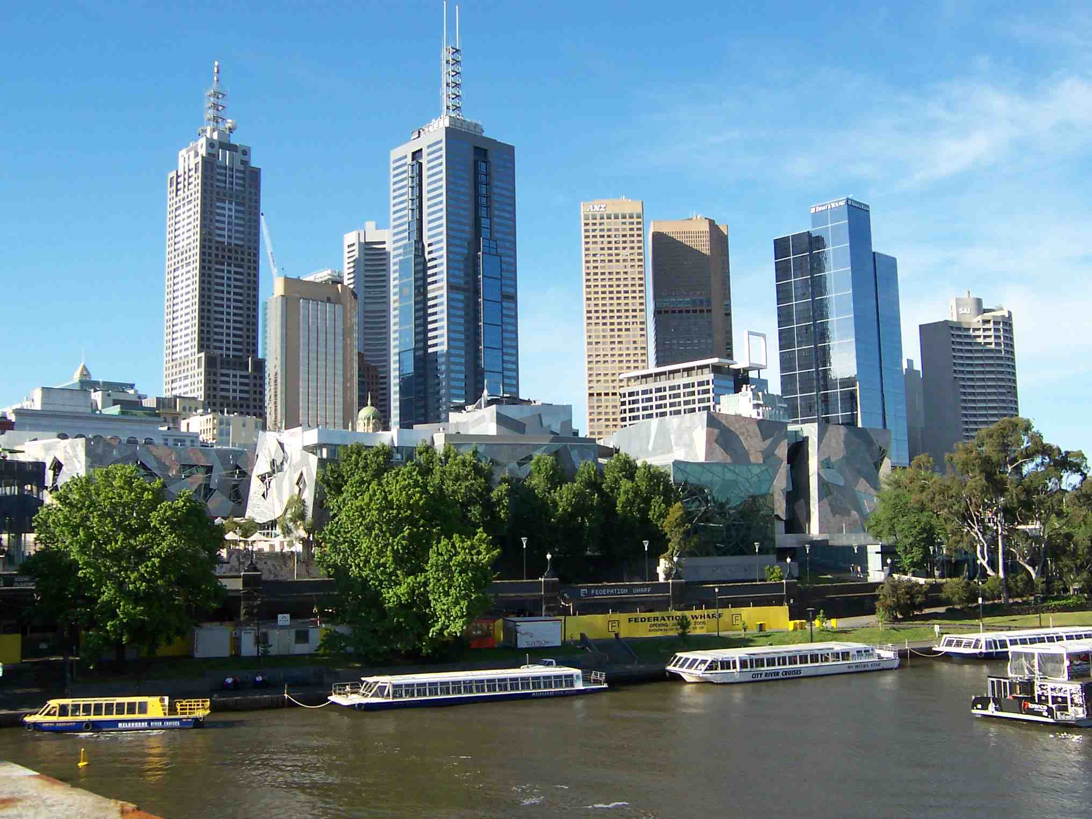
Melbourne, Australia
Image courtesy of Oliver Brunner; image source: pixelio.de
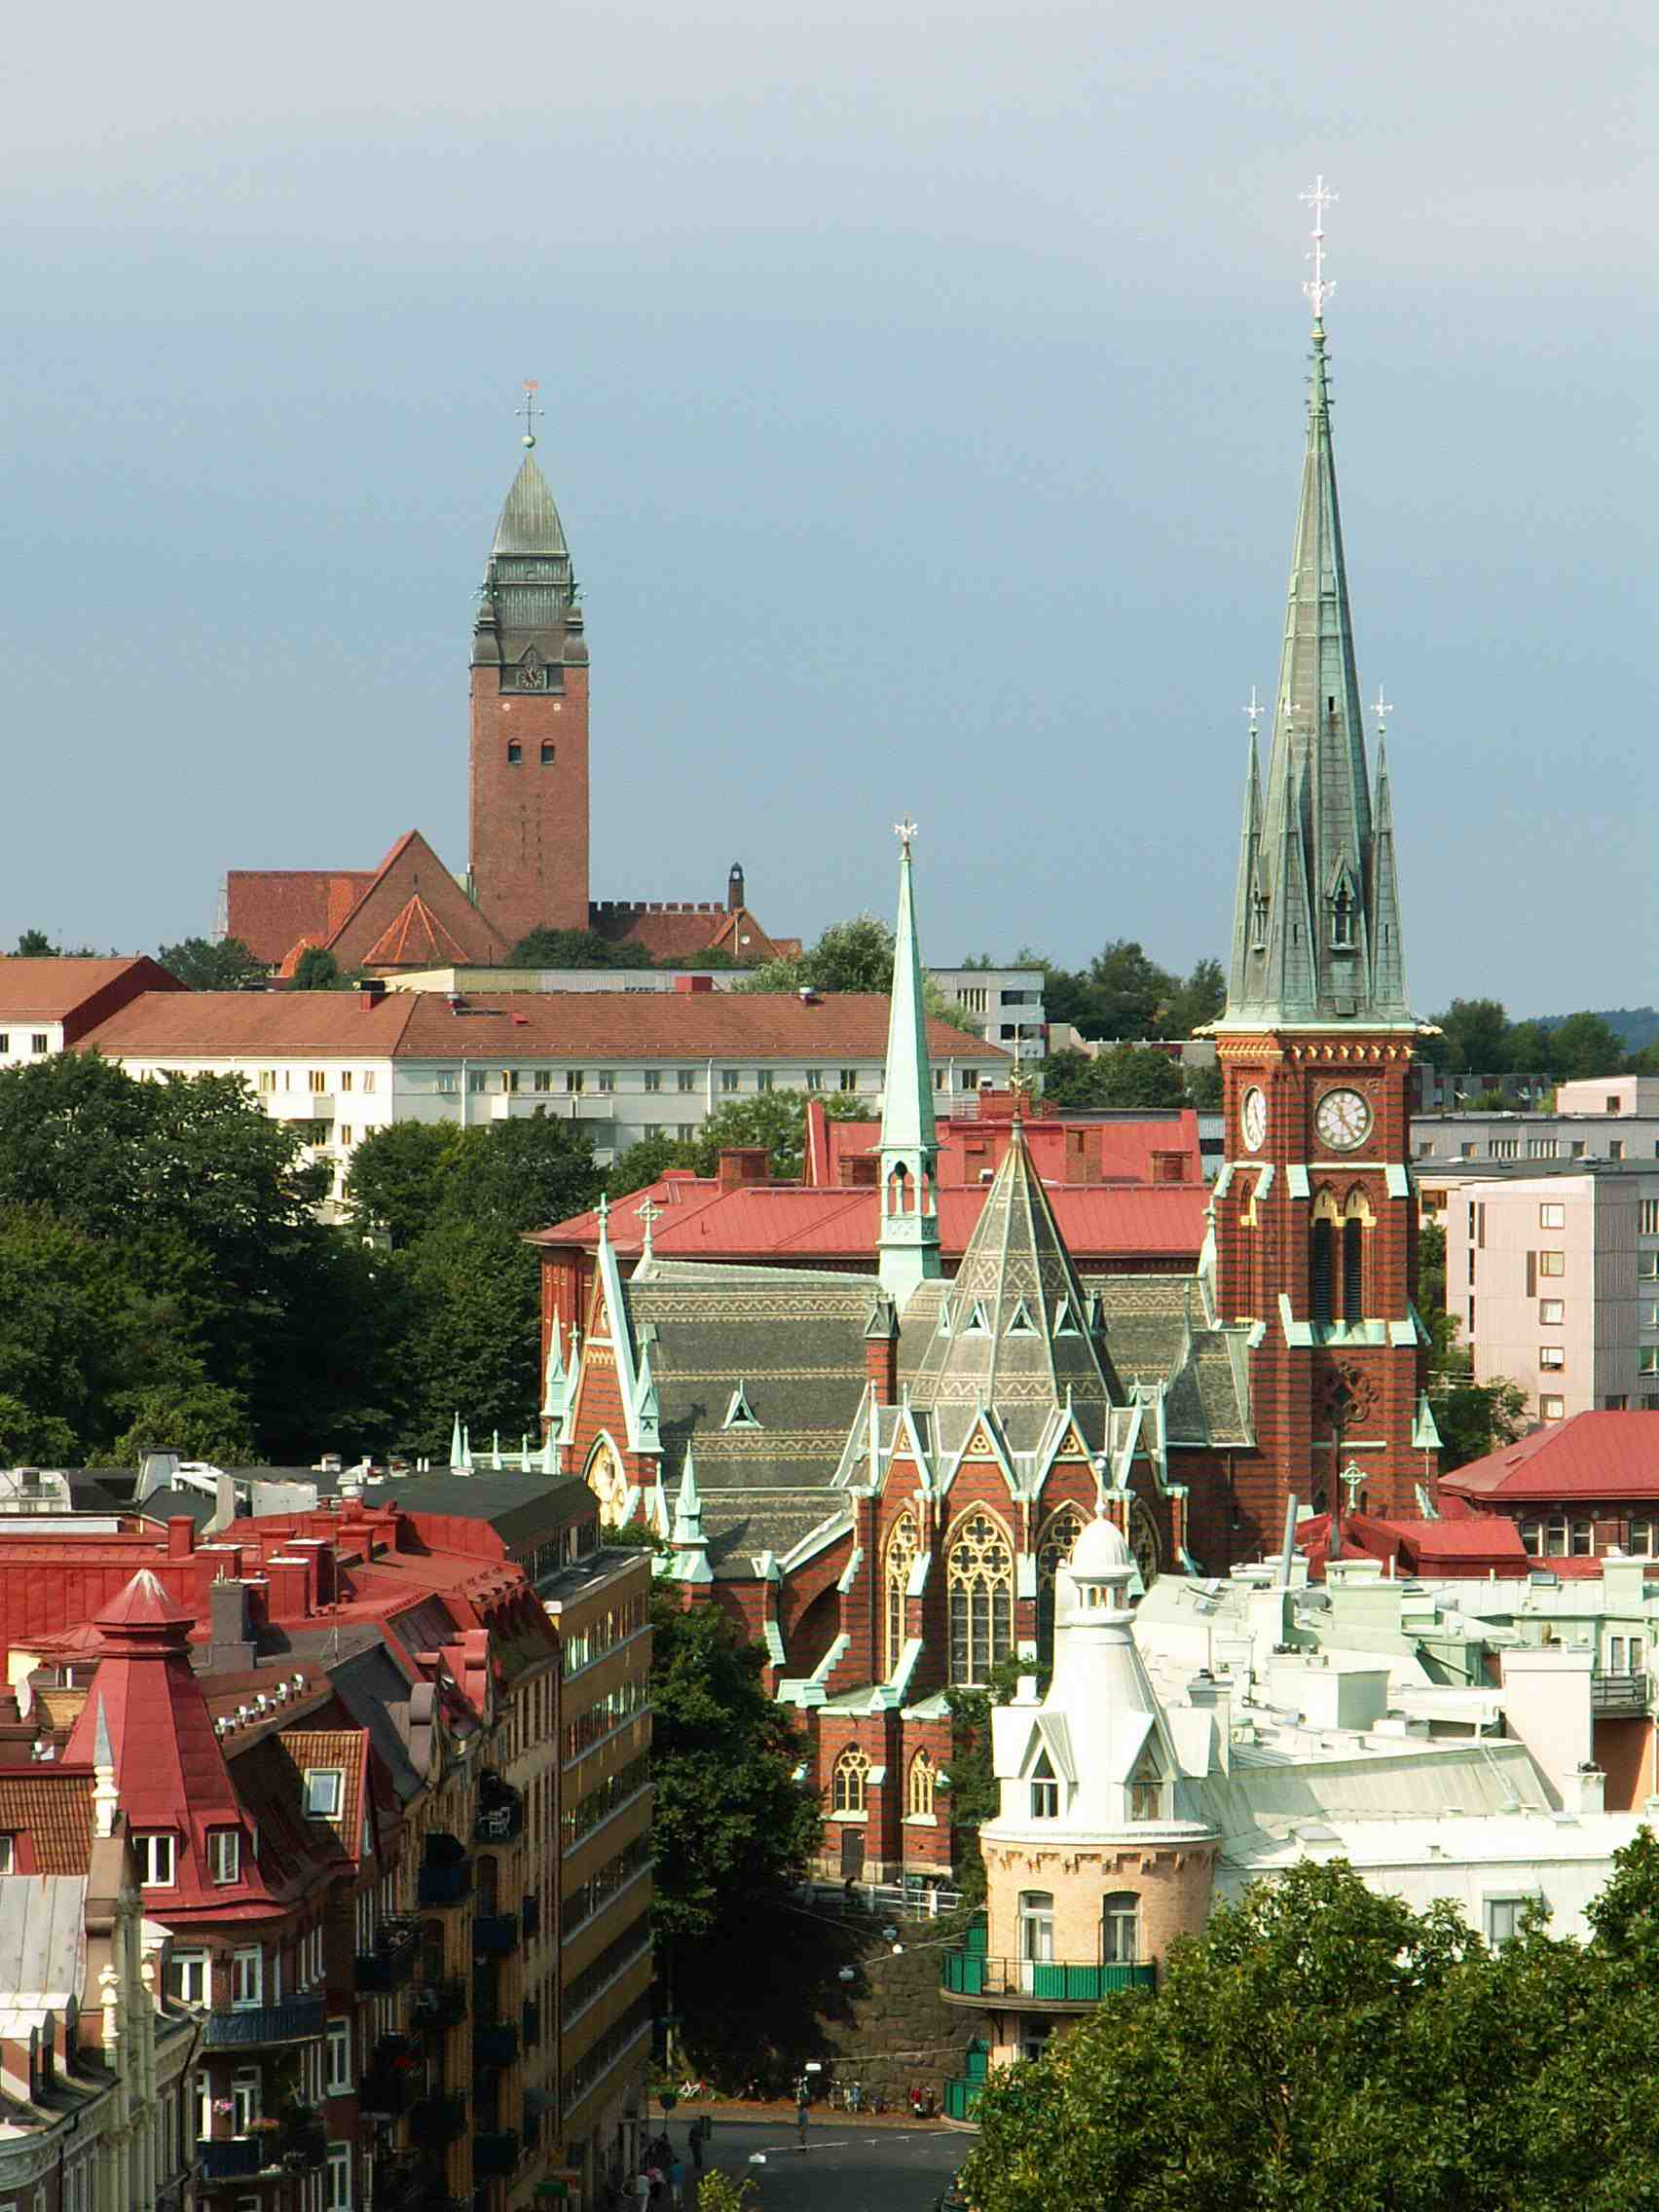
Gothenburg, Sweden
Image courtesy of jaime.silva; image source: Flickr

