Student worksheet
Safety note: Wear safety goggles. The reaction creates highly flammable gas – be careful. See also the general safety note.
- Put the metal powder mixture into an empty tea bag and stuff this into a 50 ml syringe (without the tea bag, the powder could block the syringe). Press out the air.
- Fill the 20 ml syringe with salt water and connect it to the large syringe using a three-way stopcock.
- Turn the stopcock’s valve to let the two materials flow together in the closed system.
As the reaction proceeds, gas will collect in one of the syringes.
- As soon as more than 25 ml of gas has collected, open the stopcock and let the salt water flow out, collecting it in a beaker.
Safety note: because of the resulting heat, the reaction speeds up (chain reaction). Keep a careful eye on it, to make sure you let the water out of the syringe before the gas that is produced pushes the piston out of the syringe.
- Once you have released the water, close the valve to keep the gas in the syringe, and attach the plastic tube to the valve. If gas continues to be produced, leave the valve open.
- Press the piston of the syringe to push the gas into a test tube through a pneumatic trough (use the plastic tube, bowl of water and test tube as in the diagram).
- Perform the test for hydrogen by holding the mouth of the test tube in a flame (see diagram to the right), making sure you hold the top of the tube close enough to the flame. The test should be positive.
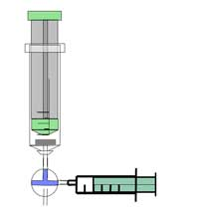
Mixing the two liquids via the three-way stopcock
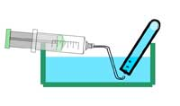
Collecting the gas
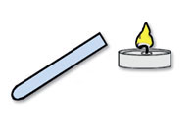
Performing the oxyhydrogen test
Images courtesy of Gregor von Borstel
Optional: add one droplet of phenolphthalein solution to the water you collected in the beaker. What happens? Why?
Health and safety note: the remaining liquids can be disposed of in the sink. Clean the plastic materials with water and leave them to dry.

